Insurance of the deliveries of a forwarding company

CIF vs. FOB: What's the Difference?

### **CIF vs. FOB: An Overview**

[Cost, Insurance, and Freight](https://www.investopedia.com/terms/c/cif.asp) (CIF) and [Free on Board](https://www.investopedia.com/terms/f/fob.asp) (FOB) are international shipping agreements used in the transportation of goods between a buyer and a seller. They are among the most common of the 12 international commerce terms (Incoterms) established by the International Chamber of Commerce (ICC) in 1936. The specific definitions vary somewhat in every country, but, in general, both contracts [specify origin and destination](https://www.investopedia.com/ask/answers/052515/what-distinction-between-free-board-fob-shipping-point-and-destination.asp) information that is used to determine where liability officially begins and ends, and outline the responsibilities of buyers to sellers, as well as sellers to buyers.

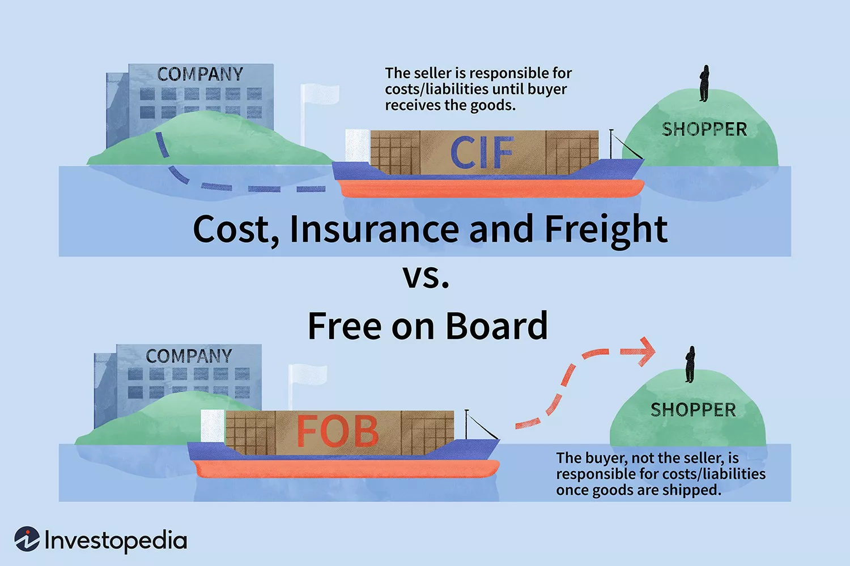

### **CIF**

CIF is considered a more expensive option when buying goods. This is because the seller uses a forwarder of his or her choice who may charge the buyer more in order to increase the profit on the transaction. Communication can also be an issue because the buyer relies solely on people who are acting on behalf of the seller. The buyer might still have to pay additional fees at the port, such as docking fees and customs clearance fees before the goods are cleared.

### **FOB**

FOB contracts relieve the seller of responsibility once the goods are shipped. After the goods have been loaded—technically, "passed the ship's rail,"—they are considered to be delivered into the control of the buyer. When the voyage begins, the buyer then assumes all liability. The buyer can, therefore, negotiate a cheaper price for the freight and insurance with a forwarder of his or her choice. In fact, some international traders seek to maximize their profits by buying FOB and selling CIF.

Important reminder: With FOB contracts, when the voyage begins, the buyer assumes all liability for the shipped goods.

### KEY TAKEAWAYS

* Cost, Insurance and Freight and Free on Board are international shipping agreements used in the transportation of goods between a buyer and a seller.
* CIF is considered a more expensive option when buying goods.
* FOB contracts relieve the seller of responsibility once the goods are shipped.

Shipping rate

Example shipping rate of a forwarding company

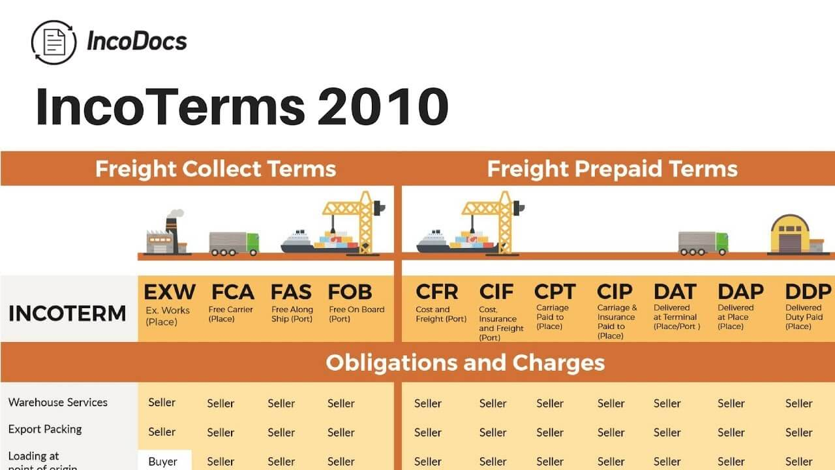

* **EXW;** also known as EX Works, this term is usually followed by the name of the destination i.e. EXW Cairo.

This means that the seller is responsible for ensuring that the goods are available at the seller’s location.

The EXW in this case will then determine where the goods are sent.

In this case, they will be sent to Cairo.

Note that in EXW, the seller is not responsible for freight costs.

* **FAS;**FAS is often followed by the name of the shipping port i.e. FAS Alexandria.

Here, the seller is responsible for transporting the goods from his factory to the named port in China.

From here, the buyer will take care of all costs of shipping the goods from the port in China to final destination.

* **FOB;**free on board which is usually followed by the name of port i.e. FOB Guangzhou. In this case, the seller will deliver the goods to the shipping port and oversee the loading of goods for shipping.

The cost of shipping from origin port to destination port will be handled by either the buyer or the seller. It depends on the agreement.

* **CFR;** this stands for Cost and Freight and is also usually followed by a named destination i.e. CFR Damietta.

In this incoterm, the seller pays for all the costs needed to transport the goods to the named destination.

All other costs are transferred to the buyer once the goods reach the named destination place.

* **CIF** or Cost Insurance and Freight is a term that is also followed by a name of port or destination i.e. CIF Alexandria.

CIF note is quite similar to CFR but with additional conditions for the seller like insurance.

Here, the seller is responsible for paying the goods insurance premium.

Note that the above are mainly departure incoterms.

There are also incoterms for arrival that determine the condition of goods as they arrive at the destination port or place.

These incoterms include, DAT (delivered at terminal), DAP (delivered at place) and DDP (delivered duty paid) just to name a few.

[**' MoazzaM '**](https://people.sap.com/moazzam.ali)

August 21, 2014 9 minute read

# Different freight scenarios and Freight calculation, freight PO determination and posting in FI.

**Scenario 2**

Freight is being paid to vendor and you have transportation module implemented. You calculate freight automatically and post it to FI. Company pays this freight and bears the expense.

I am not going into detailed configuration steps of transportation management because that is available in many links. I also assume that you have basic knowledge of Sales order processing, transportation management and purchase order process. We will post freight charges through a freight service PO and I will explain determination of this PO.

From Sales order point of view document flow would be like this.

| **Activity** | **Transaction Code** |
| --- | --- |
| Create sale order | VA01 |
| Create delivery order | VL01N/VL10A |
| Create Shipment Document | VT01N |
| Create shipment cost document | VI01 |
| Post vendor payment invoice | MIRO |

In this process you can create billing document with VF01 any time after creating delivery order. You can change the settings for billing document as per your requirement.

From STO point of view you will create STO with ME21N and create delivery with VL10B. Rest of the process would be same.

Let’s take an example and view this process in screens.

I have created a sale order, delivery and shipment document. Now creating shipment cost document. Settings for shipment type, shipment cost document type and item category type has also been shown here.

**Shipment Type**

[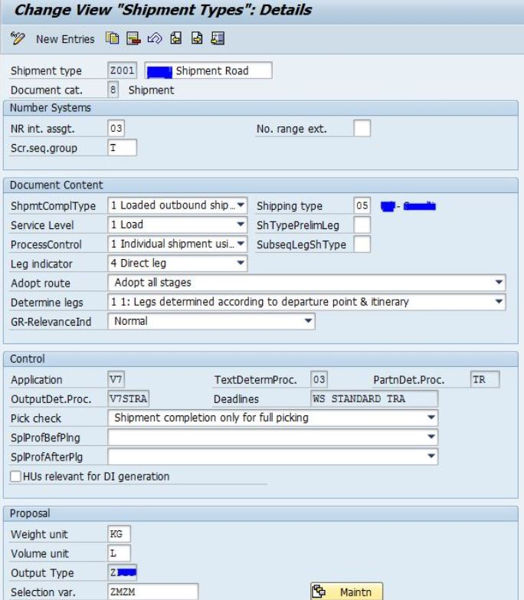](https://blogs.sap.com/wp-content/uploads/2014/08/capture_524514.jpg)

Shipment cost item category type

[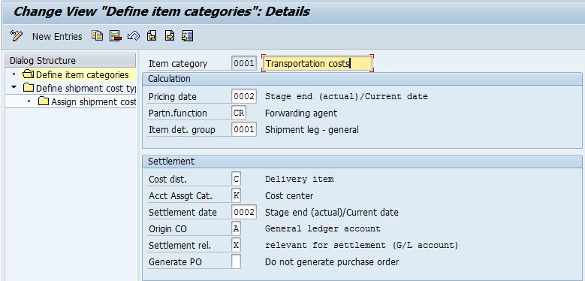](https://blogs.sap.com/wp-content/uploads/2014/08/capture_524546.jpg)

***Important Note:***    *In this above screen you can see that I am not generating PO automatically here. We can use it with both ways. Generte PO automatically or determine it using some specific fields which I’ll explain later. You can maintain here A B or C and if you dont want to create PO automatically leave this field blank.*

Shipment Cost document type and assignment of item category.

[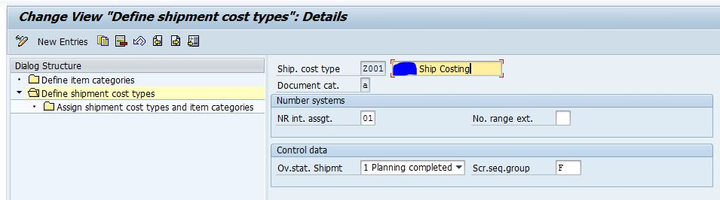](https://blogs.sap.com/wp-content/uploads/2014/08/capture_524547.jpg)

[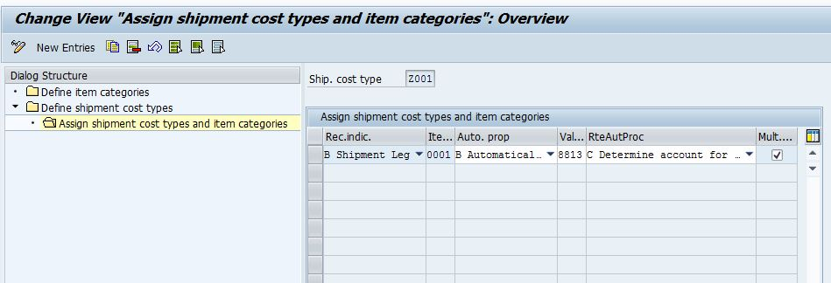](https://blogs.sap.com/wp-content/uploads/2014/08/capture_524548.jpg)

Now I am creating shipment cost document w.r.t shipment document.

[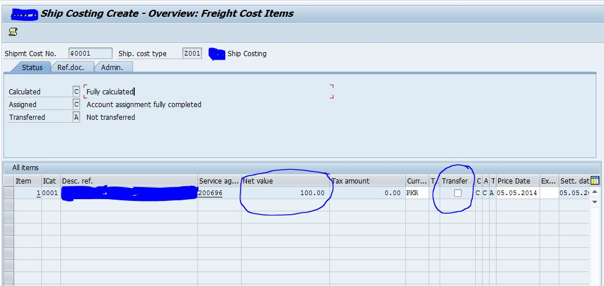](https://blogs.sap.com/wp-content/uploads/2014/08/capture_524549.jpg)

You can see that net value is calculated based on condition record maintained for departure zone, destination zone, vendor and country etc. There is transfer button which means if you mark this and save document system will post this freight charges to FI. There can be two possibilities here.

**Create PO Automatically**

As I have mentioned above that we can create PO automatically for one day one week or one month. This automatically created PO will have service entry sheet as well based on your configuration for account assignment category of PO. There will be no release strategy for this automatically created PO. At end of the period you can post one single invoice for vendor for all shipment documents.

**Determine PO**

If you want to use some release strategy for freight service PO then you don’t need to create PO automatically. You can create PO manually with ME21N. There are some specific fields which must have similar/specific values in freight service PO and shipment cost document. These fields are as follows.

Purchase Order Header

Company code

Purchasing organization

Purchasing group

Document currency

Vendor

Invoicing party

Validity start/end

Purchase Order Item

Plant

Purchase order item category

Account assignment category

Delivery date

Final invoice indicator

Block indicator

Value limit

For more information on these fields you can view SAP document which you will get in Message no. VY033 when you mark transfer button and press enter system will give you this following message.

[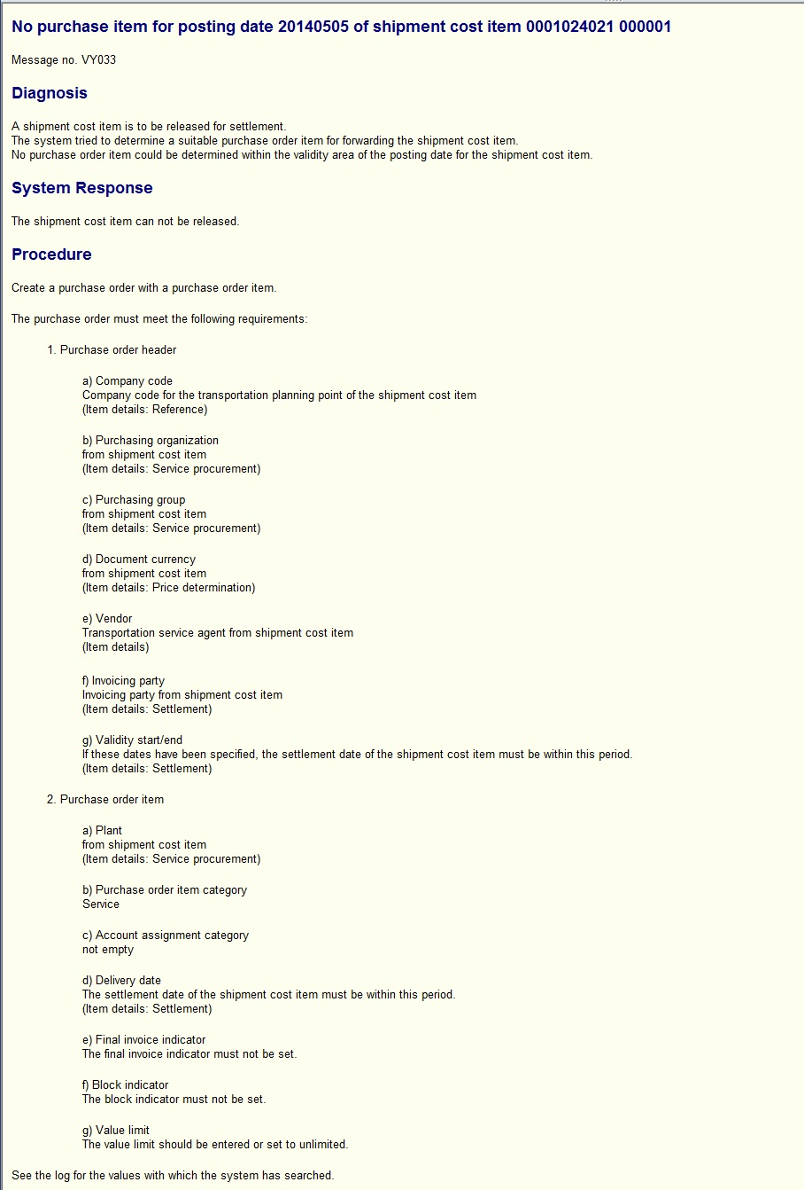](https://blogs.sap.com/wp-content/uploads/2014/08/capture_524550.jpg)

Once you create a valid freight service PO system wont give you this message and will post freight charges in that freight service PO. Let me show you in below screen.

[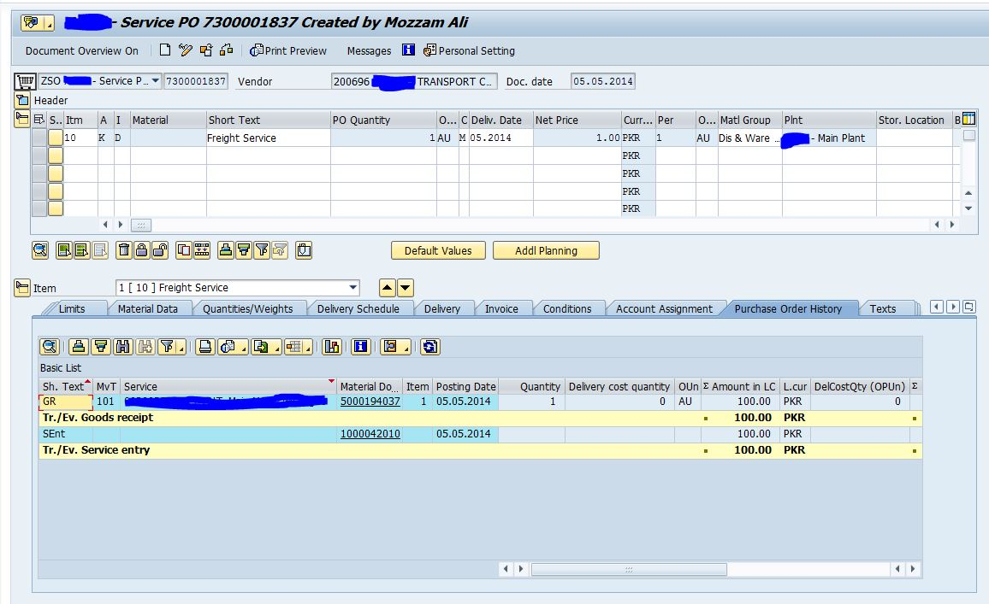](https://blogs.sap.com/wp-content/uploads/2014/08/capture_524551.jpg)

I created this PO with identical fields in shipment cost document. Then I marked the transfer field in VI02 and saved. System posted this in this freight service PO with following accounting entry.

[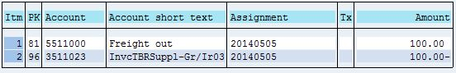](https://blogs.sap.com/wp-content/uploads/2014/08/capture_524552.jpg)

After this what you have to do is just post vendor payment through MIRO. System will credit the vendor and debit the GR/IR account. Following would be accounting entry and purchase order history view.

[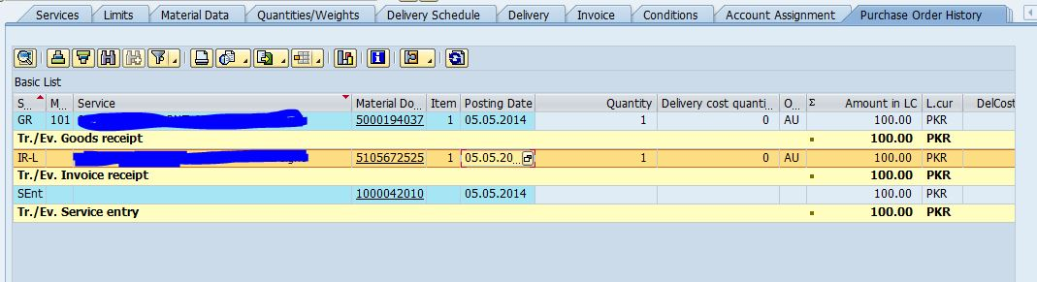](https://blogs.sap.com/wp-content/uploads/2014/08/capture_524553.jpg)

[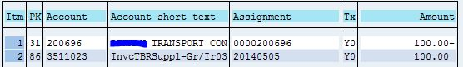](https://blogs.sap.com/wp-content/uploads/2014/08/capture_524554.jpg)

Scenario 2 is completed here. Though this is very lengthy process and there can be a lot of screens but as I said earlier I have just shared important screens and assuming that you know rest of the process. If you still have any confusion related to this scenario, you can ask me.

**Scenario 3**

Freight is being paid to vendor and you have transportation module implemented. You calculate freight automatically and post it to FI. Comapny doens’t pay this freight but charges to customers.

This scenario is same as scenario 2 but with one additional settings which is to copy freight from shipment cost document to SD billing document in VF01. For this we have certain controls in copy control of billing document, pricing procedure of shipment cost document and pricing procedure of billing document.

All the settings would be same as in scenario 2 except following which I am explaining in detail. We can also say that following are the prerequisites for copying freight from shipment cost document to billing document.

**Condition type for Customer Freight**

In shipment cost document you calculate freight automatically. Now it is upto you that whether you want to bill the same amount to customer which you have paid to vendor or you want to add some margin in it. If you want to bill the same then you don’t need to create any separate condition in shipment document pricing procedure. If you want to add some margin then you need to create new condition and add margin using automatic calculation or you may also enter this condition manually. In case of separate condition you need to mark it as static so that it doesn’t influence the freight charges which we have to transfer to FI using freight service PO. In my case I am taking 100% of freight charges which we are paying to vendor. This is just a test case and there is no rule for taking 100%.

Condition type for customer freight in Transportation IMG node

[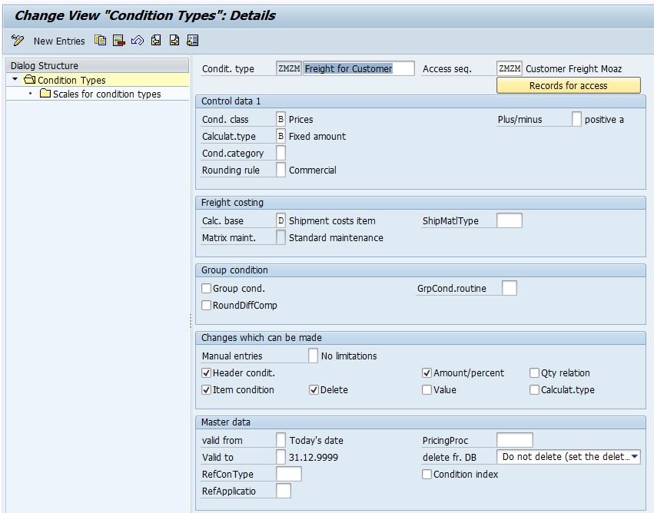](https://blogs.sap.com/wp-content/uploads/2014/08/capture_524555.jpg)

Add this condition type in shipment cost document pricing procedure

[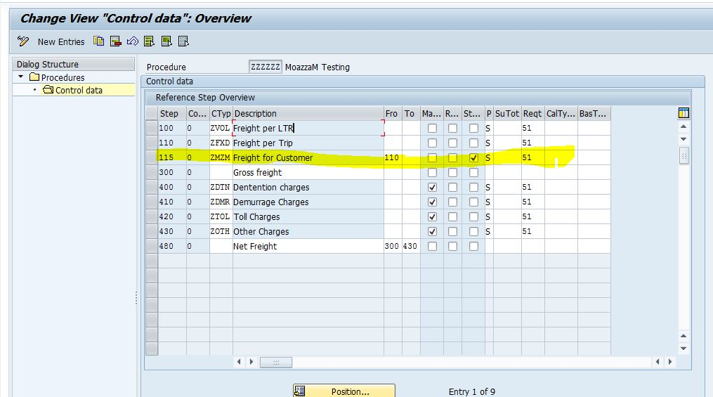](https://blogs.sap.com/wp-content/uploads/2014/08/capture_524556.jpg)

**Condition Type for Billing Document**

You must create condition type with same name as it is in shipment cost document pricing procedure. Add this condition type in billing document pricing procedure and assign account key. You also need to mark this condition as manual so that it can copy freight value from shipment cost document.

Condition type

[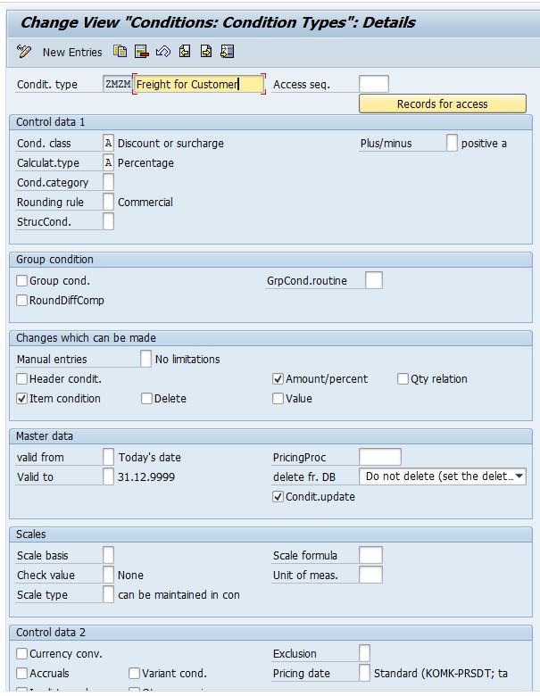](https://blogs.sap.com/wp-content/uploads/2014/08/capture_524557.jpg)

Add this condition type in billing pricing procedure. Here you also need to mark ***Transaction-specific pricing procedure*** in V/08 for billing document pricing procedure. This will make sure that static tick mark for this condition is redetermined. Check the F1 help of this field for further details.

[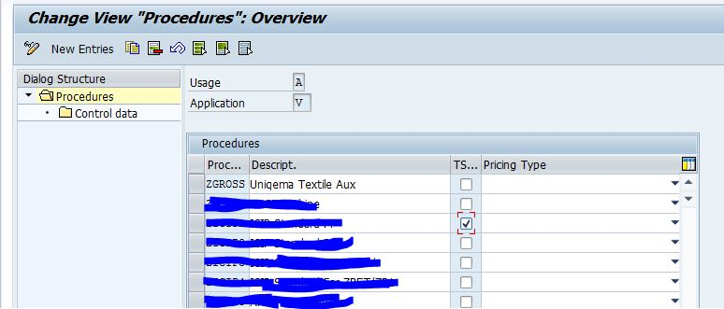](https://blogs.sap.com/wp-content/uploads/2014/08/capture_524558.jpg)

[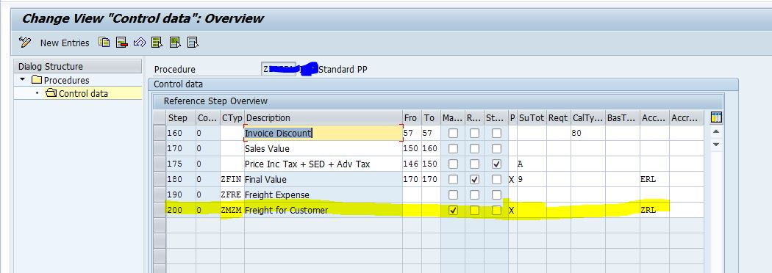](https://blogs.sap.com/wp-content/uploads/2014/08/capture_524559.jpg)

After this you need to make sure two more aspects. Number one is that you have maintained **F** in copy control from delivery to billing document in **VTFL**. Check for the item category you are using.

[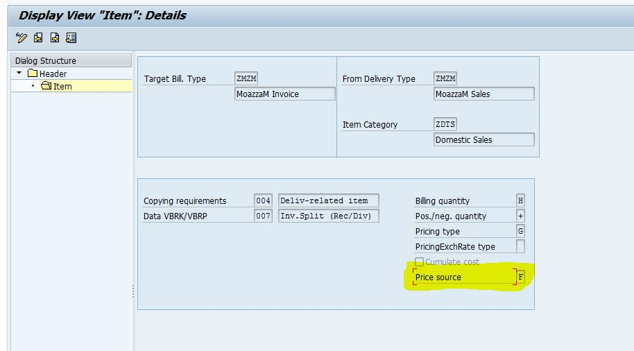](https://blogs.sap.com/wp-content/uploads/2014/08/capture_524560.jpg)

In shipment document status for Overall status of ***calculation of shipment costs for shipment VTTK-FBGST*** must be Completed. In my case I am using stage level shipment so header level is not relevant for calculation but stage level is calculated so the status is complete.

[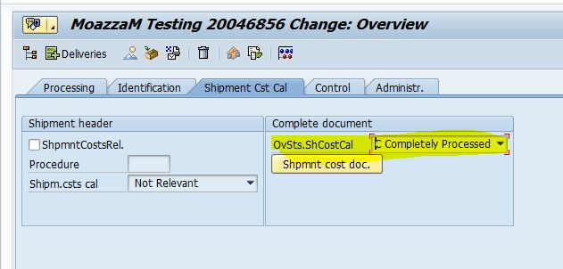](https://blogs.sap.com/wp-content/uploads/2014/08/capture_524561.jpg)

If all these settings have been made in your system then you can add customer freight condition in shipment cost document. If you are using same conditinon for customer and transporter/vendor freight then you just need to check that whether it is calculated or not. In my case I have made **ZMZM** condition in shipment cost document and in billing document.

Shipment cost document condition tab and its payment to transporter/vendor.

[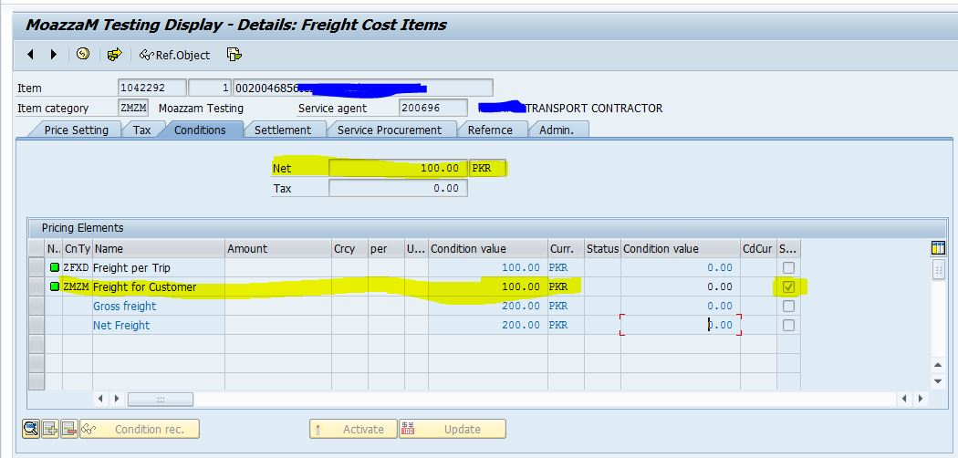](https://blogs.sap.com/wp-content/uploads/2014/08/capture_524562.jpg)

[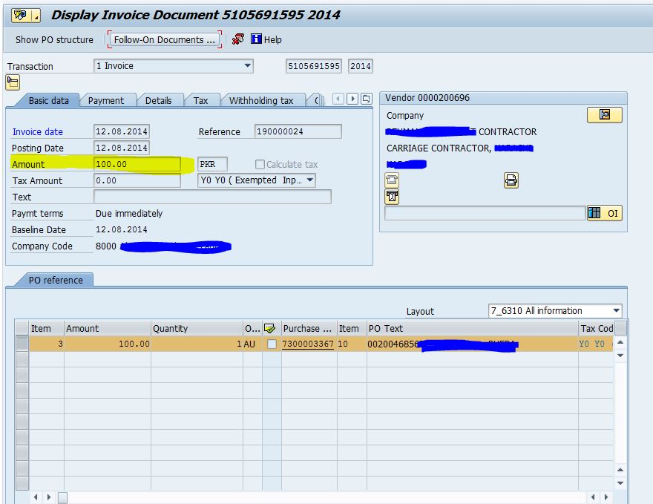](https://blogs.sap.com/wp-content/uploads/2014/08/capture_524563.jpg)

[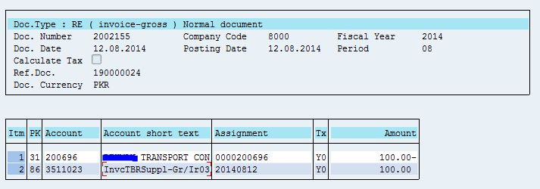](https://blogs.sap.com/wp-content/uploads/2014/08/capture_524564.jpg)

Billing Document of customer and its accounting document.

[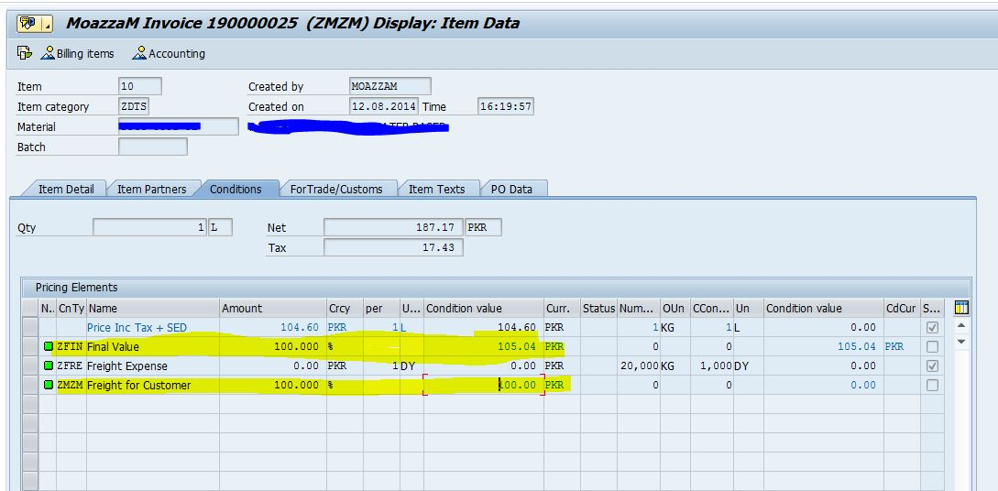](https://blogs.sap.com/wp-content/uploads/2014/08/capture_524565.jpg)

[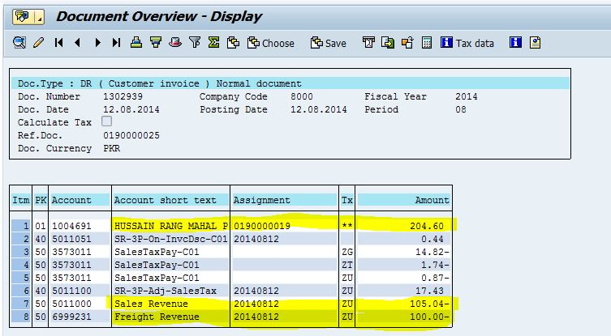](https://blogs.sap.com/wp-content/uploads/2014/08/capture_524566.jpg)

In this document you can see that sales value is 105.04 and freight which we are charging to customer is 100. Both revenues are posted in separate general leedgers and customer has been debited with 204.60. This is my test case and you can make settings as per your own requirement.

**Scenario 4**

Company has it’s own transportation vehicles and it doesn’t pay freight to any vendor but calculates and charges this separately to customer.

In this case settings are same as in scenario 3. You only need to do is one thing is that don’t create a service PO and don’t trasnfer it to FI. All other settings would be same.

**Scenario 5**

Company pays freight to vendor and charge this freight to material price in plant to plant transfer under same company code. This freight is calculated in shipment cost document automatically.

This scenario only works for the materials which have pricing price control **V Moving average price** in material master data. For price control S you have to implement material ledger and freight cost would be charged to material price when you run closing cycyle in material ledger. For further information yo can view a thread I raised for this in [my this link](http://scn.sap.com/thread/3538733).

For configuring this scenario you need to take care of following things.

Activate pricing for STO and add freight value condition with no value in STO. For this you can follow the below path.

[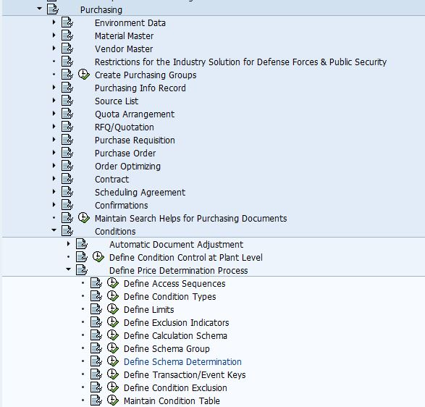](https://blogs.sap.com/wp-content/uploads/2014/08/capture_524567.jpg)

In condition type of STO pricing procedure which you will enter with no value, activate the copy shipment cost by checking this below field.

[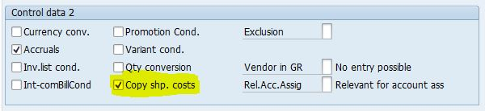](https://blogs.sap.com/wp-content/uploads/2014/08/capture_524568.jpg)

Condition FRB1 with no value in PO

[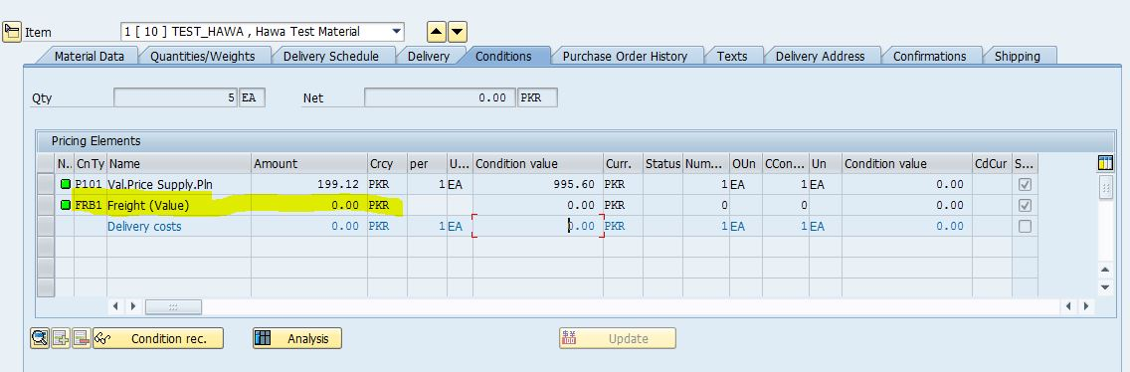](https://blogs.sap.com/wp-content/uploads/2014/08/capture_524569.jpg)

When you create STO > Outbound Delivery ***you must not PGI it before you create shipment cost document***. If you PGI it before shipment cost document, system won’t charge the price to material. Create STO > Outbount delivery > Shipment Document > Shipment Cost Document and after that PGI. In this shipment cost document you won’t see the transfer action box which we use to transfer cost in FI. Reason behind this is that cost would be charged to material and GR/IR account will also be posted with credit value when you do PGI.

Shipment Cost Document without transfer action box.

[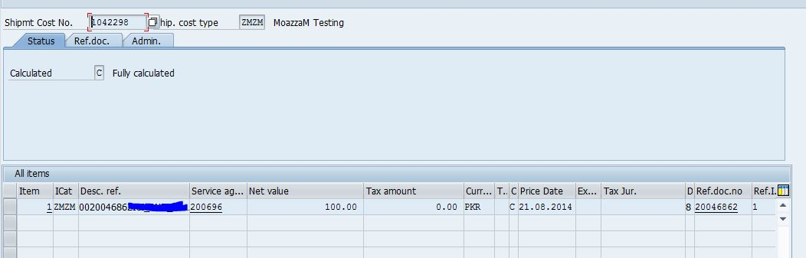](https://blogs.sap.com/wp-content/uploads/2014/08/capture_524570.jpg)

Accounting Document when you PGI. You can see the debit and credit entries difference and also GR/IR credit entry.

[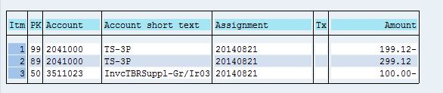](https://blogs.sap.com/wp-content/uploads/2014/08/capture_524571.jpg)

Below is the accounting document which is created at the time of MIRO when you pay the freight value to transporter.

[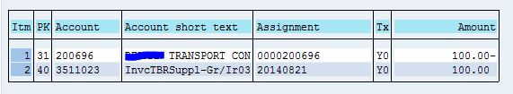](https://blogs.sap.com/wp-content/uploads/2014/08/capture_524572.jpg)

These are few scenarios which comes in my mind. There could be many others but if you know all of these I think you can configure the system the way you want. With little tweakings all other scenarios could be covered.

If I have missed something or you have something to add in this document please write me in comments. I would be happy to see positive/negative feedbacks because I always learn from it.

I have spent enough time to learn and test all these scenarios on my own but I would like to thank [**Jürgen L**](http://scn.sap.com/people/jrgen.lins)and **[Lakshmipathi G](http://scn.sap.com/people/lakshmipathi.ganesan)**because I got guidance from these two SAP Masters.

Credit by google(sap blog, Investopedia, incodocs),